Ex.No. 2

Date:

**DDL Commands with Constraints – PRIMARY, FOREIGN KEY, UNIQUE, CHECK**

**AIM:**

To add the constraints like primary key, foreign key, unique key and check using DDL commands.

1) Alter the table STUDENT with following structure.

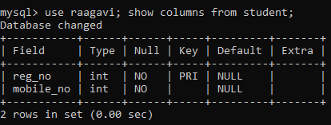

1. Alter the table name FACULTY with following structure. The DeptNo in this table refers the DeptNo in the DEPARTMENT table.

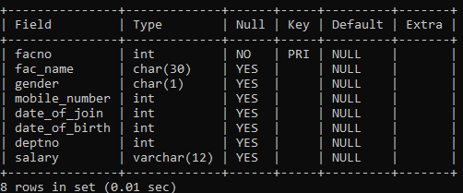

|  |  |
| --- | --- |
| 4) | Alter the table name DEPARTMENT with following structure. |

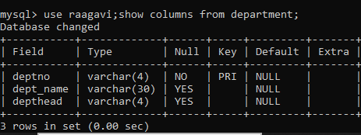

|  |  |
| --- | --- |
| 5) | Alter the table name COURSE with following structure. |



**Result:**

DDL Commands with Primary, Foreign, Unique, Check constraints are updated and verified.